AI IN BUSINESS
Case Study Analysis Project
Robotics and AI for Smart Factory Automation
mobica Automotive Glass Manufacturing Factory — Egypt
MBA Student | Mahmoud Abdalmaguid Abdullah Mohamed
Course | AI in Business
Institution | Smart Village Campus
Submission Date | March 2026

Abstract
This case study examines the AI and robotics transformation of mobica Automotive Glass Manufacturing Factory a greenfield investment established in 2025 within Egypt's 6th of October Industrial Zone, targeting an annual production capacity of 700,000 glass units across three export markets: Egypt (40%), Turkey (35%), and Morocco (25%).
When operations first got underway, the factory was struggling across virtually every performance dimension. The defect rate stood at 12.5%, unplanned downtime was eating into 18% of production hours, material waste reached 17.5%, and the unit cost of $45.20 made it genuinely difficult to compete against established Chinese and European suppliers. Something had to change — and change significantly.
A $4.2 million AI and robotics transformation programme, delivered over 18 months from January 2025 to June 2026, addressed these problems through four interconnected technologies: computer vision for quality inspection, predictive maintenance, cutting layout optimization, and demand forecasting all tightly integrated with SAP S/4HANA. The results have been striking. The defect rate fell by 72%, Overall Equipment Effectiveness (OEE) climbed from 68% to 87%, unit cost dropped to $32.80, and on-time delivery reached 96%. Financially, the $4.2M investment generated a net annual benefit of $9.5M with a payback period of just 5.3 months.
This report analyses the business context that made this transformation necessary, the data and AI architecture that enabled it, and the broader organizational and strategic implications including the risks and ethical considerations that any responsible AI deployment must confront.

1. INDUSTRY & BUSINESS CONTEXT

1.1 Overview of the Industry
The global automotive glass market is a sizeable industry, valued at roughly $32 billion annually, with the dominant players being Saint-Gobain Sekurit, AGC Inc., Fuyao Glass, and Guardian Industries (Fuyao Glass Industry Group, 2024). Every product in this space must meet ECE R43 standards covering optical clarity, structural integrity, and breakage characteristics there is no flexibility on compliance.
Two forces are currently reshaping the competitive landscape. First, vehicle electrification dramatically expands what glass needs to do: ADAS sensor integration, heads-up displays, and embedded heating systems all place new technical demands on manufacturers. Second, Industry 4.0 is raising the baseline productivity expectations across the sector (World Economic Forum, 2025). For a regional manufacturer like mobica, this is simultaneously a threat and an opportunity the MENA region's government-backed localization programs in Egypt and Morocco are creating genuine openings, but only for manufacturers who can credibly match quality standards that were previously the preserve of European incumbents.

1.2 mobica Factory Profile
The table below summarizes the key parameters of the factory as it was set up:
Parameter | Details
Location | Industrial Zone, 6th of October, Egypt
Established | 2025 (Greenfield Investment)
Annual Capacity | 700,000 pieces (100,000 vehicle sets)
Products | Laminated windshields, tempered side/rear glass, sunroof panels
Total Investment | $20 million (incl. $4.2M AI/automation)
Workforce | 90 direct + 30 management/technical staff
Certifications | ISO 9001, IATF 16949, E-Mark ECE R43, ISO 27001:2022
Markets | Egypt 40%, Turkey 35%, Morocco 25%
Key Customers | Nissan Egypt, GME, Ghabbour Auto, MG, EIT, Proton & Aftermarket
Table 1: mobica Factory Profile

1.3 Key Business Challenges Before AI Adoption
Before the AI program was initiated, mobica was facing six compounding operational problems that reinforced one another in a damaging cycle. Quality inspection was handled manually by six shift inspectors, an approach that proved insufficient, resulting in a 12.5% defect rate and approximately 45 customer complaints per month. Unplanned equipment downtime consumed 18% of available production time, costing an estimated $3.2M annually. Glass cutting was performed based on operator experience rather than optimized algorithms, generating 17.5% material waste and a $2.1M annual loss. On the safety side, 45 workers were engaged in manual glass handling, recording eight to twelve injuries every year. Paper-based reporting introduced a consistent week-long blind spot in management visibility. And at $45.20 per unit with an 8% stockout rate, the factory was being excluded from OEM contracts worth $3–5M annually.
Taken individually, any one of these problems would be serious. Together, they created a strategic trap that conventional improvement methods could not break.

1.4 Market Conditions and Competitive Environment
At the time of the analysis, European producers were selling in the $38–42 per unit range, backed by decades of established quality credentials. Chinese manufacturers were undercutting with $28–32 per unit pricing. With mobica at $45.20 and a 12.5% defect rate, the factory found itself in what Porter and Heppelmann (2014) describe as a 'stuck in the middle' position more expensive than Chinese competitors yet without the quality reputation to justify a European-level premium. The government localization programs offered a real window of opportunity, but accessing it required a fundamental shift in how the factory operated.

2. PROBLEM STATEMENT

2.1 Core Business Problem
If I had to distil mobica's fundamental challenge into a single sentence, it would be this: the factory was unable to generate, interpret, and act on production intelligence in real time. Every department quality, maintenance, supply chain, planning was making decisions based on incomplete or delayed information, always reacting to problems rather than anticipating them (Lee et al., 2015).
This is not a problem that incremental improvement can solve. Manual inspection cannot reliably achieve sub-3% defect rates across extended production shifts; reactive maintenance is incapable of preventing the failures it responds to; and paper-based reporting introduces structural information delays into every management decision. The tools that built the factory could not fix it.

2.2 The Three Gaps That Had to Close
Working through the data, three mutually reinforcing gaps defined the strategic problem that the AI program had to address.
The operational gap: OEE of 68% against an industry benchmark of 85%+, representing approximately 180,000 units of foregone annual output output the factory had the physical capacity to produce but could not realise. The strategic gap: complete exclusion from OEM contracts worth $3–5M per year because the factory's quality and delivery performance did not meet the minimum thresholds these customers require. The financial gap: a unit cost of $45.20 running roughly 20% above the competitive threshold, driven upward by defect-related rework, unplanned downtime compressing available capacity, and delayed information preventing timely corrective action.
Each gap made the others worse. A solution that addressed only one or two dimensions would leave the cycle intact. This is why the case for a comprehensive AI and robotics program rather than targeted point solutions was ultimately compelling.

3. DATA ANALYTICS COMPONENT

3.1 Types of Data and Sources
The AI systems at mobica draw on three distinct categories of data. Structured data makes up roughly 60% of total volume and includes SAP S/4HANA records over one million production work orders (PP module), more than 500,000 quality inspection records (QM), 1,800 equipment maintenance events (PM) combined with continuous feeds from over 200 IoT sensors distributed across the production floor. Unstructured data accounts for approximately 35%: 500,000 high-resolution defect photographs and free-text maintenance notes, which often contain diagnostic observations that never make it into structured fields. Real-time streaming data only 5% by volume but operationally critical includes 200GB of daily sensor readings, millisecond production counters, and 30fps inspection camera feeds.
All data streams are ingested through Apache Kafka (capable of handling 100,000 messages per second) into a 150TB Azure Data Lake, with Power BI dashboards providing live visibility across the factory. The architecture was designed from the outset to handle both the volume and the velocity of manufacturing data two dimensions that conventional BI infrastructure typically struggles with.

3.2 KPIs and Metrics Before vs. After AI
The table below captures the performance improvements across the full set of tracked KPIs:
Category | KPI | Before AI | After AI
Production | OEE | 68% | 87% ↑ +28%
Production | Cycle Time / Piece | 82 sec | 52 sec ↓ −37%
Quality | Defect Rate | 12.5% | 3.5% ↓ −72%
Quality | First Pass Yield | 87.5% | 96.5% ↑ +10%
Maintenance | Unplanned Downtime | 18% | 5% ↓ −72%
Maintenance | MTBF | 480 hrs | 850 hrs ↑ +77%
Cost | Material Waste | 17.5% | 7.8% ↓ −55%
Cost | Cost per Unit | $45.20 | $32.80 ↓ −27%
Customer | On-Time Delivery | 82% | 96% ↑ +17%
Customer | Customer Satisfaction | 3.8 / 5 | 4.6 / 5 ↑ +21%
Table 2: KPI Dashboard — Before vs. After AI Implementation
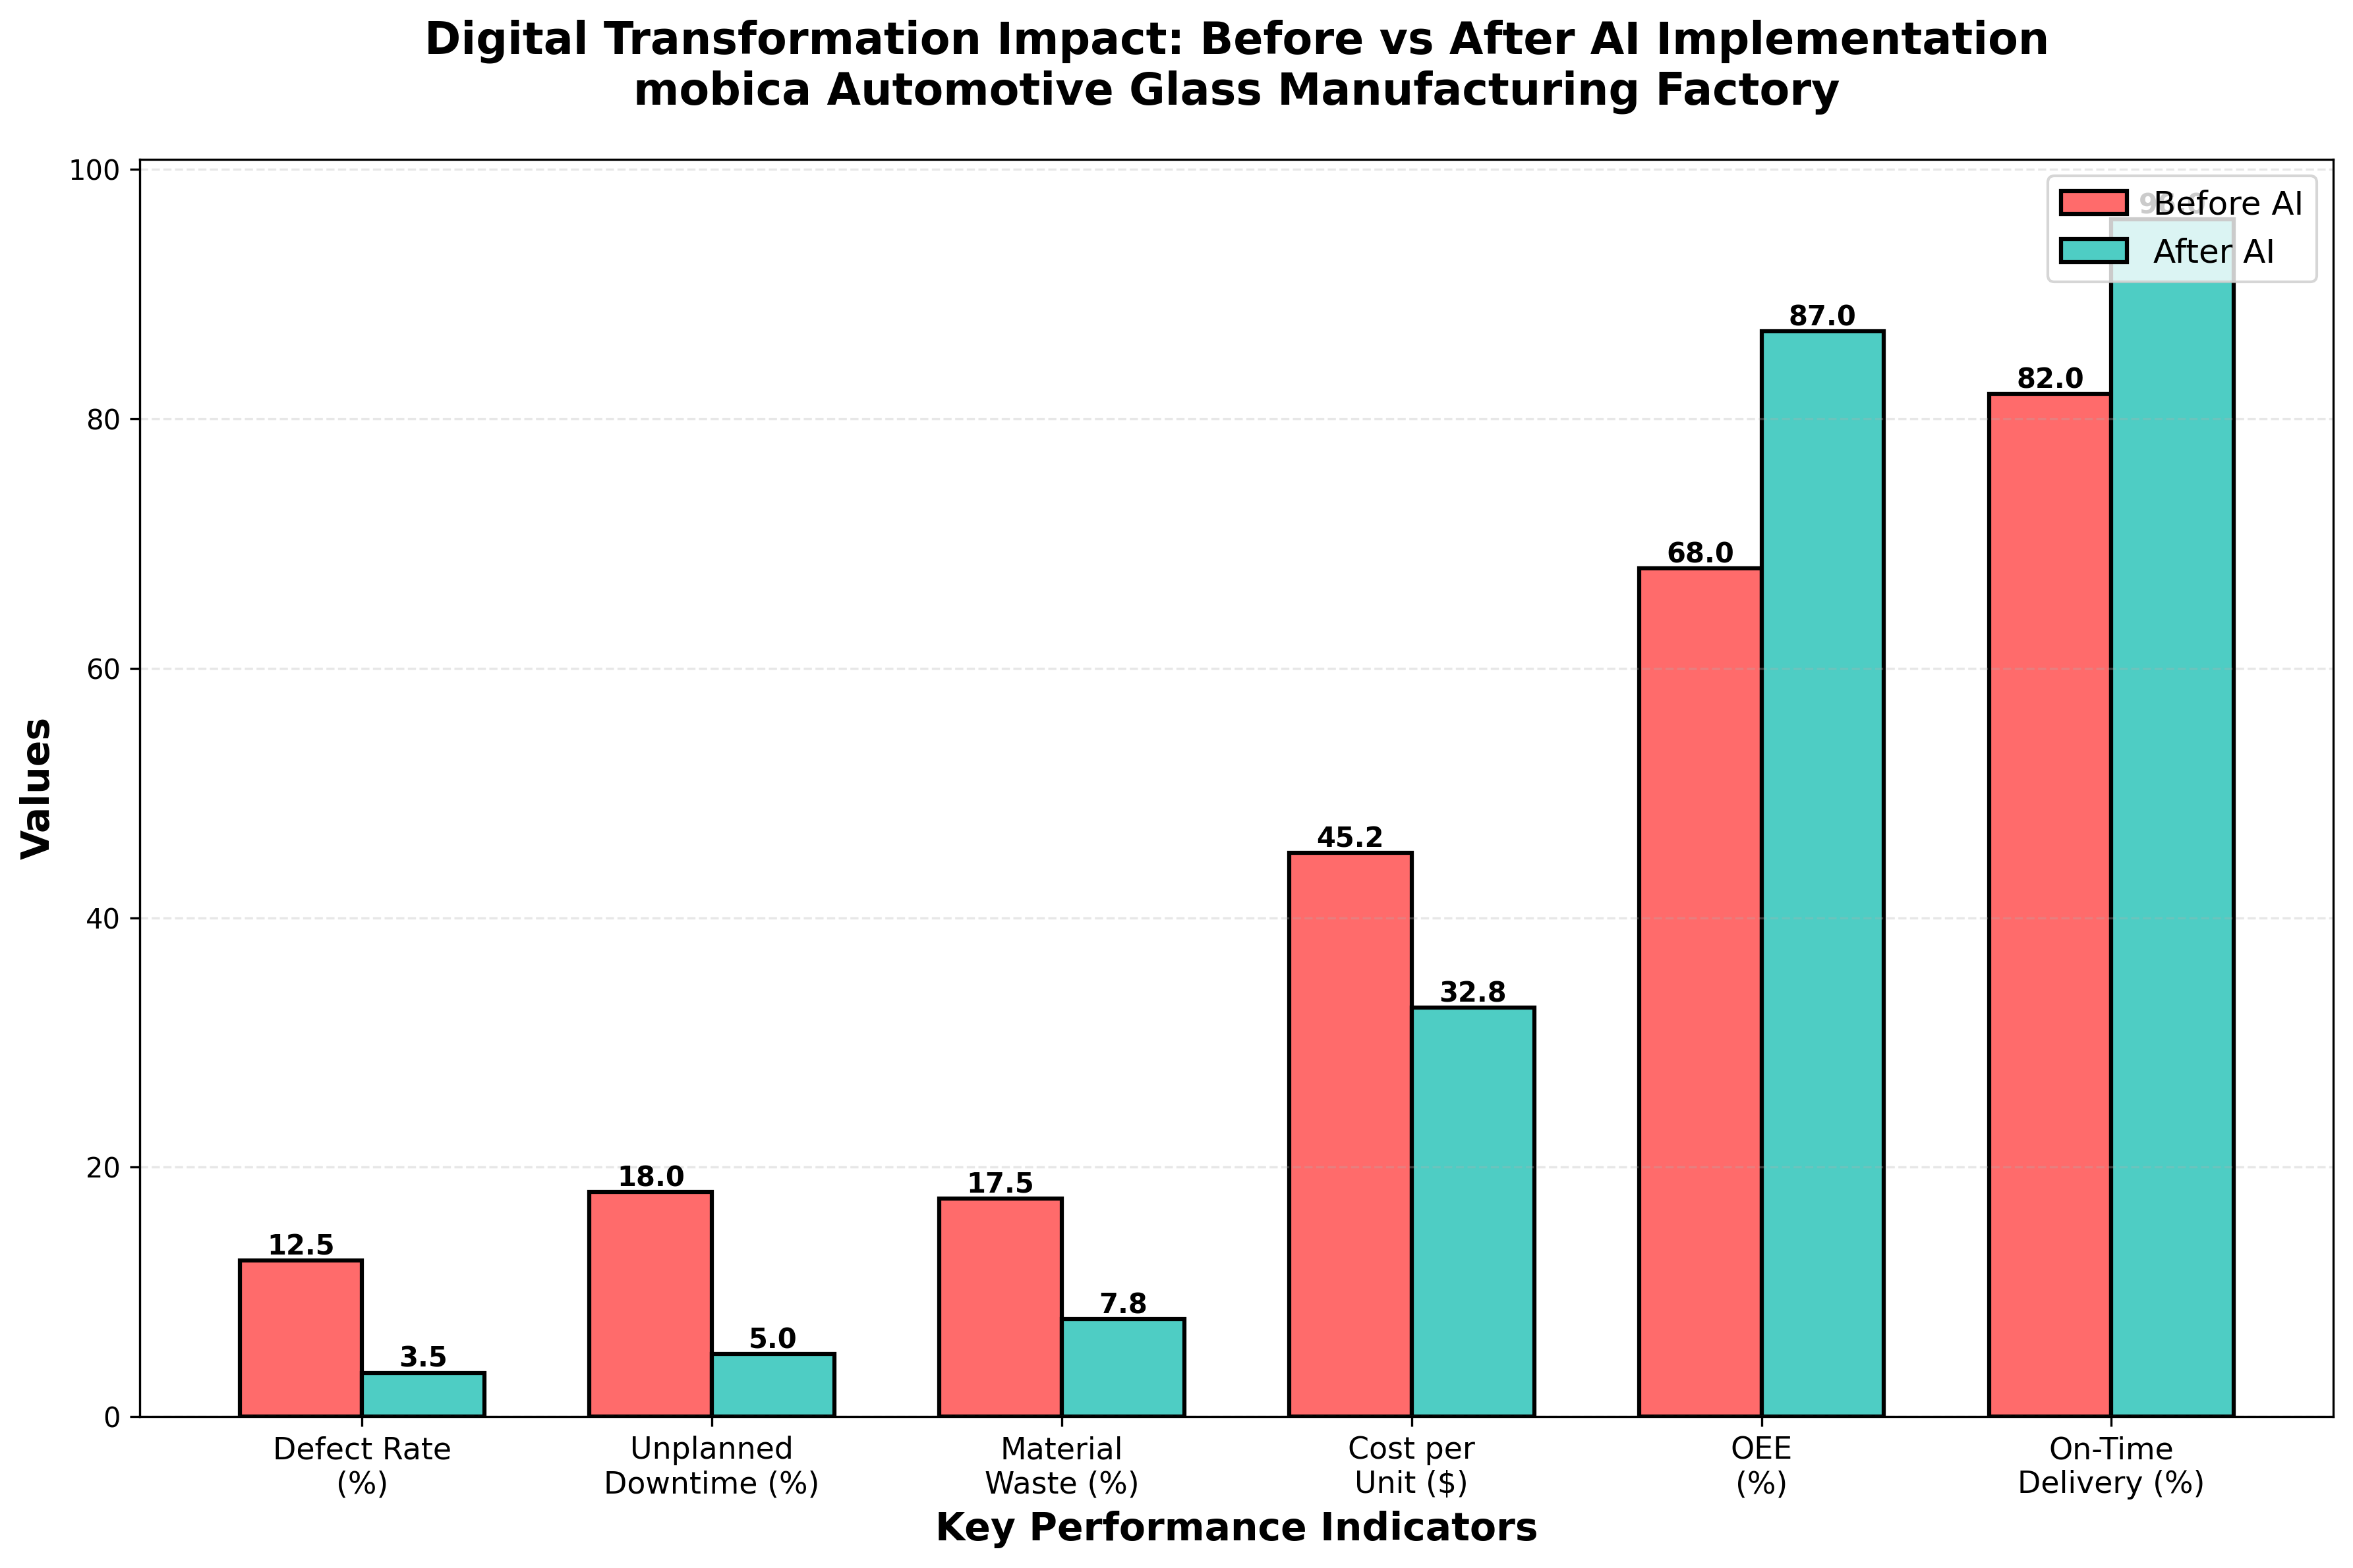
Figure 3: Before vs. After AI KPI Comparison (see Appendix for full-size version)

3.3 Decision-Making Using Data Mining Techniques
Six data mining approaches underpin the day-to-day decision-making across the factory. Classification using Decision Trees, Random Forest, and SVM predicts pass/fail outcomes from furnace temperature profiles, batch data, and ambient humidity when the model confidence drops below 94%, pre-emptive process corrections are triggered before defective units are even produced. Clustering via K-Means (k=7) and DBSCAN uncovered hidden patterns in defect data, including one particularly instructive finding: bubble defects cluster disproportionately on Monday mornings, traceable to uneven glass cooling over the weekend. Association Rule Mining with the Apriority algorithm identified a high-confidence link (89%) between summer humidity levels and lamination defects, which led directly to the installation of dehumidifiers at the relevant production stage.
Multiple regression analysis estimates Remaining Useful Life for each machine from vibration, temperature, and accumulated runtime data this is what powers the 48–72-hour maintenance advance warnings. Time Series Forecasting using ARIMA, Facebook Prophet, and LSTM networks improved demand forecast accuracy from 65% to 92%, directly informing procurement and staffing decisions. Finally, Anomaly Detection using Isolation Forest and Autoencoder models flags sensor deviations 24–48 hours before a conventional threshold alarm would trigger, enabling genuinely pre-emptive intervention.

4. AI SOLUTION OVERVIEW

4.1 AI Technologies Deployed
Four AI systems form the intelligent core of the smart factory, each addressing one of the major problem areas identified in the business case (Russell & Norvig, 2021).
Computer Vision for Quality Inspection uses a ResNet-50 CNN fine-tuned on 100,000 labelled glass defect images across 15 defect categories. Four 8-megapixel cameras return a pass/fail decision with full defect classification in under three seconds, running on NVIDIA Jetson edge hardware located directly on the production line. Predictive Maintenance combines a Random Forest classifier fed with aggregated sensor statistics and an LSTM network processing a 24-hour rolling time-series window, weighted 60%/40% in an ensemble that produces a single machine risk score per equipment item. Cutting Optimization applies to a Genetic Algorithm that evolves cutting layouts over 500 generations, supplemented by a Reinforcement Learning agent that manages production scheduling against live capacity and delivery constraints. Demand Forecasting uses a Facebook Prophet plus LSTM hybrid model generating weekly product-level and market-level forecasts at 8% MAPE (Mean Absolute Percentage Error).

4.2 Machine Learning Models (Supervised, Unsupervised, Semi-Supervised)
Supervised Learning
Supervised learning trains models on labelled input–output pairs, making it the natural fit for well-defined classification and regression tasks. The quality inspection CNN (ResNet-50) was trained on 100,000 labelled defect images using a 70/15/15 train/validation/test split and transfer learning from ImageNet weights. The predictive maintenance Random Forest was trained on labelled sensor records paired with subsequent confirmed equipment health outcomes (Goodfellow et al., 2016). The key advantage here is precision when you have enough labelled data, supervised models can reach production-grade accuracy relatively quickly.

Unsupervised Learning
Unsupervised learning discovers hidden structure in data without requiring labels which is valuable precisely because most factory data has never been labelled. The anomaly detection Autoencoder (encoder architecture: 128→64→32→16 nodes, with a mirrored decoder) learns the normal operating signature of each piece of equipment and flags high reconstruction error as anomalous. The K-Means and DBSCAN clustering approaches applied to the defect database uncovered the Monday bubble pattern and several other latent root-cause relationships that had never previously been identified through manual analysis.
Semi-Supervised Learning
Semi-supervised learning bridges the gap between the two approaches it starts with a small, labelled dataset and uses it to generate pseudo-labels for a much larger unlabeled pool. The cutting optimization system started with 1,000 expert-validated layouts, used these to generate pseudo-labels for 100,000 historical cuts (accepting only those with model confidence ≥95%), and retrained iteratively before passing the enriched model into the Genetic Algorithm. The result was a 55% reduction in material waste.

4.3 Robotic Process Automation (RPA)
Seven industrial robots and five Automated Guided Vehicles (AGVs) now handle glass across eight production stations (Siemens AG, 2024), eliminating the manual glass handling that previously caused eight to twelve injuries per year. The specific deployment is worth describing in some detail, because the choice of robot and task is not arbitrary.
An ABB IRB 6700 handles sheet loading at 25 seconds per sheet with zero manual injuries since installation. A KUKA KR 120 executes the AI-optimized cutting patterns. A Fanuc M-710iC handles furnace loading at 700°C, a task no human should be performing continuously. A four-camera array runs the computer vision inspection at 15 times the speed of manual inspection. A KUKA KR 240 manages packaging at 99.9% barcode accuracy. Five AGVs (each rated for 1,000 kg) handle 24/7 warehouse operations. A Siemens PLC S7-1500 master controller coordinates the entire fleet, integrating with both the MES and SAP ERP. The workforce transition from 45 manual handlers to 8 robot operators was achieved through reskilling rather than redundancy, which I would consider one of the more consequential design decisions in the whole program.

4.4 SDLC Methodology
The program followed an Agile-Waterfall hybrid over 18 months. The table below summarizes each phase:
Phase | Duration | Key Activities & Outputs
1-Planning | Months 1–2 | Stakeholder requirements; feasibility assessment; $4.2M budget and project charter approved.
2-Analysis | Months 3–4 | Current-state process mapping; functional requirements (latency <3 sec, 99.5% availability); ISO 27001 compliance signed off.
3-Design | Months 5–6 | Cloud vs. edge architecture decisions; AI model specifications; SAP integration touchpoints; security architecture.
4-Development | Months 7–12 | 16 Agile sprints: data pipelines → quality AI → predictive maintenance → optimization → SAP connectors → dashboards. CI/CD throughout.
5-Testing | Months 13–15 | SIT, UAT, performance testing; 2-week live pilot on one production line; independent ISO 27001 audit.
6-Deployment | Months 16–18 | Staged go-live (10%→50%→100%); 40 hours role-specific operator training; closed June 2026 at $4.1M (under budget).
7- Maintenance | Ongoing | 24/7 support; 15-minute critical issue SLA; quarterly AI model retraining; 99.5% availability target.
Table 3: SDLC Phase Summary — Agile-Waterfall Hybrid (18 Months)

5. ANALYTICAL TECHNIQUES

5.1 Four-Category Analytics Framework
The analytics capability at mobica spans all four levels of the standard framework from descriptive through to prescriptive. The table below maps each category to the tools used and the tangible business value it delivered:
Technique | Tools | Application at mobica | Business Value
Descriptive (What happened?) | Power BI, SAP Analytics, pandas | Real-time OEE dashboards, defect distribution, shift summaries | Replaced weekly paper reports with live management visibility
Diagnostic (Why did it happen?) | scikit-learn, Minitab, R | Bubble defects traced to Monday restarts; Furnace B degradation linked to batch failures | Systematic causal identification replaces blame attribution
Predictive (What will happen?) | TensorFlow, Azure ML | Equipment failure 48–72 hrs ahead; demand forecast 92% accuracy; quality risk flagged pre-production | Prevention becomes the default operating mode
Prescriptive (What should we do?) | OR-Tools, CPLEX, AnyLogic | Cutting layout optimization (−55% waste); scheduling efficiency (+25%); AGV route planning | Automated optimization across all major resource decisions
Table 4: Four-Category Analytics Framework Applied at mobica
What strikes me most about this framework, as applied here, is the progression. Most manufacturers have some version of descriptive analytics in place. Fewer have systematic diagnostic capability. Predictive is where genuine competitive advantage starts to accumulate and prescriptive, where the system not only tells you what will happen but recommends what to do about it, is where the real productivity step-change occurs.

6. DIGITAL TRANSFORMATION ANALYSIS

6.1 Changes in Business Processes and Workflows
Five core processes were fundamentally re-engineered by the transformation, rather than simply automated. Production planning: the previous weekly Excel-based cycle gave way to an AI scheduler connected directly to SAP PP demand forecasts at 92% accuracy now drive MRP automatically, and the order cycle time halved from 12–15 days to 5–7 days. Quality control: six shift inspectors were replaced by an automated vision station that processes every unit in under three seconds, bringing the defect rate from 12.5% down to 3.5%. Maintenance: AI-generated predictions provide a 48–72-hour window that enables planned maintenance during low-production periods instead of emergency response; unplanned downtime fell from 18% to 5%. Inventory: AGV and RFID-driven movements now post automatically to SAP MM in real time, eliminating the weekly manual stock count and reducing stockout rate from 8% to 0.8%. Order-to-delivery: a real-time ATP engine commits delivery dates based on actual capacity data rather than estimates, improving on-time delivery from 82% to 96%.

6.2 Automation of Manual Tasks
Forty-two previous manual tasks were automated as part of the transformation, recovering approximately 18,000 labor hours per year. The most significant of these include glass handling and movement, defect classification, production event logging, inventory reconciliation, purchase requisition creation, quality certificate generation, and export documentation. In workforce terms, the headcount transitioned from 120 to 90 employees, a 25% reduction achieved entirely through reskilling into higher-value roles, with average wages increasing 15% (Kagermann et al., 2013). Workers moved from repetitive manual handling into robot operator and AI supervisor positions. This is the transformation model I would advocate for: productivity improvement that shares the benefit with the workforce rather than simply extracting it.

6.3 Organizational Culture and Decision-Making
The cultural dimension of this transformation is, in some ways, more important than the technical one. Four shifts stand out. From instinct to evidence: decisions at all levels are now anchored in data rather than accumulated experience and gut feeling. From reaction to anticipation: predicted failures and pre-production quality flags have replaced crisis management as the default operational mode. From departmental silos to shared visibility: a single Power BI dashboard gives every level of organization the same real-time factory picture. From centralized to distributed decision authority: operators now have the information they need to adjust their own processes without escalating.
It is worth being candid about the human side of this change. Initial workforce resistance ran at around 30%, which is lower than I would have expected for a transformation of this scale. The turning point was a firm public commitment to no redundancies, combined with visible performance improvements that workers could see within the first three months. By year-end, acceptance had reached 95%.

6.4 Customer Experience — Before vs. After
Dimension | Before | After
Quality | 12.5% defects; 45 complaints/mo; 3.2% returns | 3.5% defects; 8 complaints/mo; 0.8% returns
Speed | 12–15 day order cycle; 82% OTD | 5–7 day order cycle; 96% OTD
Transparency | Weekly reports only | Live dashboards; instant quality notifications
OEM Eligibility | Not qualifying | Fully OEM-qualified (IATF 16949, ISO 27001)
Satisfaction | 3.8 / 5.0 | 4.6 / 5.0 (+21%)
Table 5: Customer Experience — Before vs. After Digital Transformation

7. ERP INTEGRATION & ROLE

7.1 SAP S/4HANA Modules Involved
The AI systems do not operate in isolation their value is substantially amplified by deep integration with SAP S/4HANA across six modules:
Module | AI Integration & Function | Key Result
PP/Production Planning | AI demand forecasts feed MRP; AI scheduler proposes daily work order sequences; IoT sensors auto-confirm completions | Planning cycle: weekly → real-time; order cycle halved
QM/ Quality Management | Vision system defect detections auto-raise QM notifications with images and root-cause data; Certificates of Analysis generated automatically on batch release | Reporting lag: 1 week → real-time
MM/ Materials Management | AGV/RFID movements post goods transactions automatically; AI auto-raises purchase requisitions when stock hits safety levels | Inventory accuracy: 92% → 99.8%; stockouts: 8% → 0.8%
PM-Plant Maintenance | Predictive model raises PM work orders with failure mode, spare parts list, and optimal maintenance window | Maintenance costs ↓35%; downtime: 18% → 5%
SD-Sales & Distribution | Real-time ATP check on each order; delivery dates committed algorithmically; 98% export documents auto generated | On-time delivery: 82% → 96%
FI/CO/Finance & Controlling | Every production event posts to accounts in real time; profitability visible by product and customer without period-end wait | Month-close process: 10 days → 3 days
Table 6: SAP S/4HANA Modules — AI Integration Summary
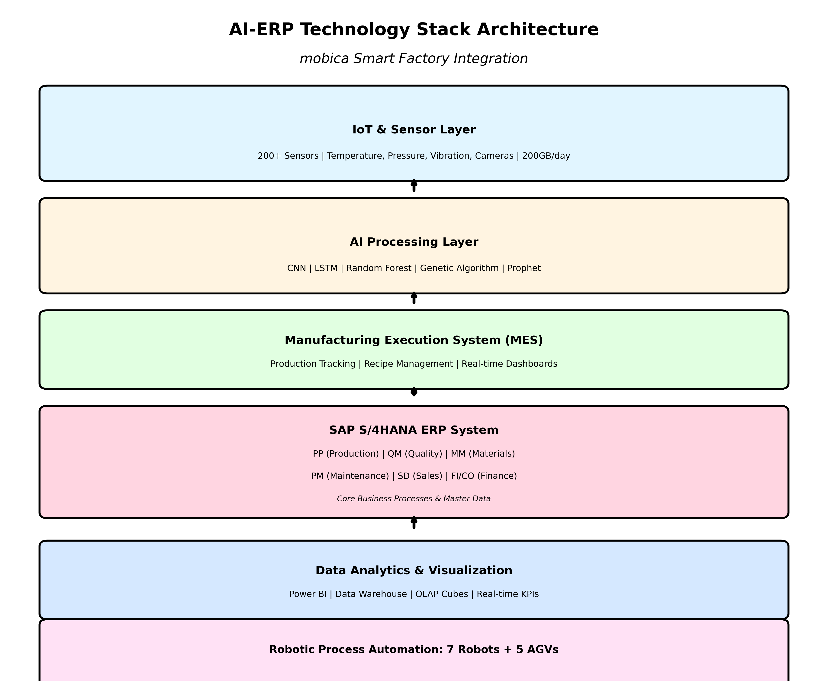
Figure 7: AI-ERP Technology Stack — Four-Layer Integration Architecture

7.2 Data Flow Between AI Tools and ERP
The integration between AI systems and SAP is genuinely bidirectional and continuous which is what makes it qualitatively different from a conventional one-way reporting integration. Outbound (AI to SAP): the vision system creates QM notifications from defect detections; robot cycle completions confirm PP work orders; AGV movements post MM inventory transactions; and the scheduling algorithm proposes PP production sequences. Inbound (SAP to AI): material batch properties inform the quality inspection model's context; equipment records provide the maintenance AI with historical failure context; and live customer orders feed the demand forecast.
Three middleware layers handle different latency demands. Layer 1 (real-time operations) uses SAP PI/PO, REST APIs, and OData services. Layer 2 (bulk data transfer) uses Apache Kafka and Change Data Capture. Layer 3 (analytics) connects Power BI, SAP Analytics Cloud, and the Azure Data Lake. Each layer was engineered for its specific performance requirements rather than applying a single integration approach to everything.

7.3 Benefits, Challenges & ERP Process Flows
The integration enabled four capabilities that the AI systems alone could not provide: a closed-loop quality cycle where AI-detected defects immediately trigger investigation workflows in SAP QM; autonomous maintenance coordination from prediction through to parts procurement; demand-driven materials management that adjusts automatically to forecast changes; and real-time financial tracking where every production event flows immediately to accounts.
The integration challenges were real and deserve honest acknowledgment. Aggregating 200GB of daily IoT data at the edge before entry into SAP required purpose-built data reduction logic. Achieving real-time latency for certain critical processes requires direct database reads that go beyond standard API capabilities. And minimizing customization scope using standard User Exits and BAdIs wherever possible rather than modifications required active discipline to protect the factory's upgrade path as SAP releases new versions.

7.4 ERP–AI Integration Flowchart and BPM Diagram
The BPM swim lane diagram below maps the end-to-end production process across five actors, showing how AI decisions and ERP transactions interlock throughout the production cycle.
Actor | Process Flow (left → right)
Customer / SAP SD | [START] Order Received → ATP Check (Live Capacity) → Delivery Date Confirmed → Sales Order in SAP SD → Released to Production
Production Planning (SAP PP + AI) | AI Demand Forecast → MRP Run → AI Scheduler Optimizes Sequence → Work Orders Generated → Material Requisition (SAP MM) → Raw Glass Procured
Manufacturing (Robots + IoT) | ABB Robot Loads Glass → KUKA CNC Cutting (GA-Optimized) → Tempering Furnace 700°C → IoT Streams Data → [Maintenance Alert?] YES → PM Work Order / NO → Continue → Work Order Confirmed in SAP PP
Quality Control (CV-AI / SAP QM) | 4-Camera Array → CNN ResNet-50 Classifies (<3 sec) → [Pass?] FAIL → QM Notification + Reject / PASS → Certificate of Analysis Auto-Generated → Batch Released
Warehouse / Logistics (AGV + SAP MM/SD) | AGV Transports → RFID Posts Goods Receipt (SAP MM) → Stock Updated Real-Time → Picking & Packing → Export Docs Auto-Generated (SAP SD) → Shipment → [END] Delivery Confirmed
Figure 1: Smart Factory BPM Swimlane Diagram — End-to-End Production Process
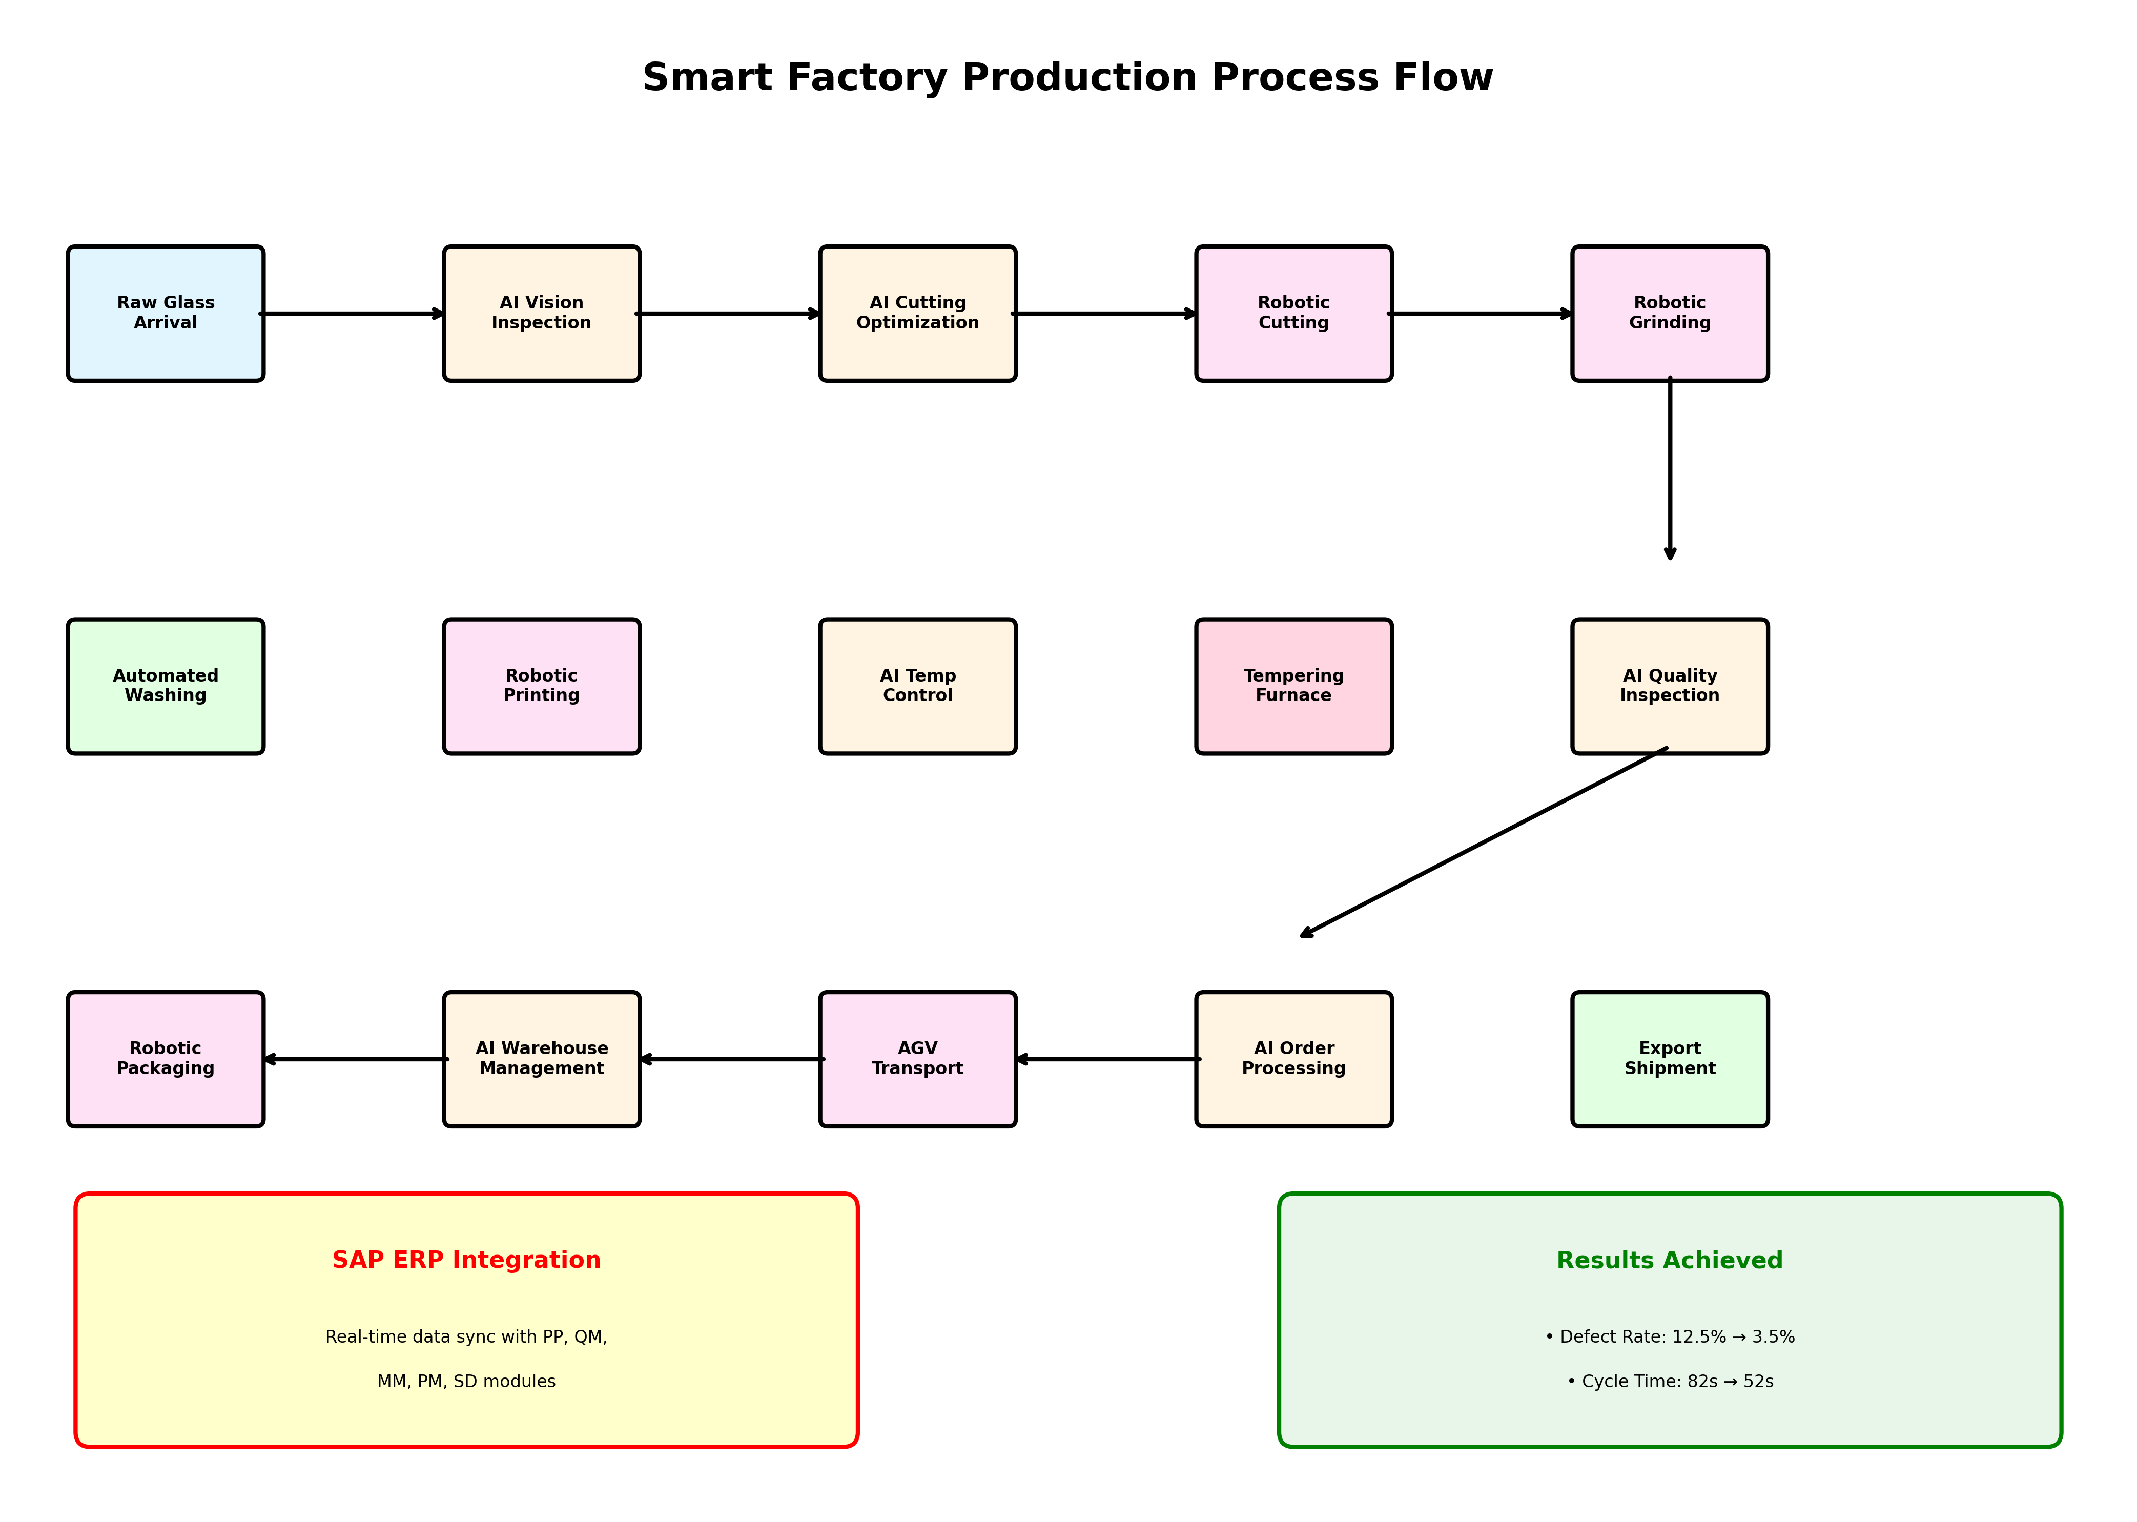
Figure 8: Smart Factory Production Process Flow — Before vs. After AI

8. BUSINESS IMPACT & VALUE CREATION

8.1 Financial Impact and ROI
Financial Metric | Value | Notes
Total Investment | $4.2 Million | AI, robotics, IoT, ERP integration, cloud infrastructure, training
Annual Cost Savings | $10.3 Million | Quality $3.2M | Downtime $2.4M | Waste $1.6M | Labor $1.1M | Revenue $2.0M
Annual Operating Cost (AI) | $0.8 Million | Licenses, maintenance, technical staffing
Net Annual Benefit | $9.5 Million | Total savings net of ongoing AI operating costs
Payback Period | 5.3 Months | $4.2M ÷ $9.5M × 12
3-Year NPV | $19.4 Million | Discounted at 10% WACC
3-Year ROI | 579% total (193%/yr) | ($28.5M − $4.2M) ÷ $4.2M × 100
EBITDA — Before AI | $2.2M (12% margin) | Baseline pre-transformation
EBITDA — After AI | $11.7M (34% margin) | Net improvement of $9.5M (+433%)
Table 7: Financial Impact Summary
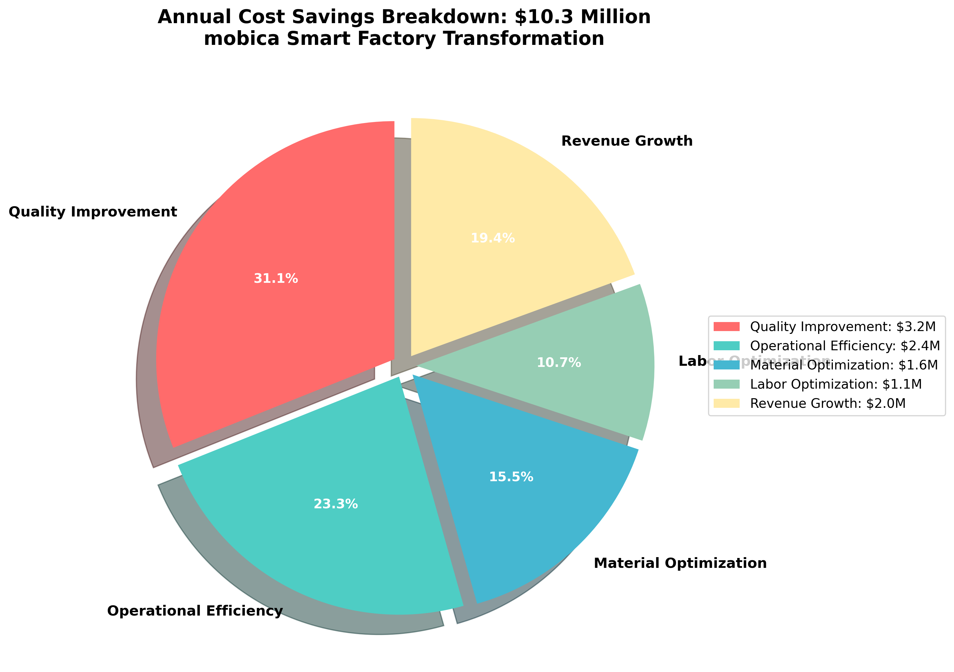
Figure 4: Annual Cost Savings Distribution by Category
The financial case for this investment is, frankly, unusually strong. A 5.3-month payback on a $4.2M capital investment is a result that most manufacturing investment proposals would struggle to match. The EBITDA improvement from 12% to 34% margin transforms mobica from a marginal competitor into a genuinely profitable regional operation. The 3-year NPV of $19.4M at a 10% discount rate means the investment creates almost five times its cost in present value terms over a relatively short horizon.

8.2 Operational & Strategic Value
Beyond the headline financials, the transformation delivered value in dimensions that are harder to quantify but arguably more important in the long run. OEE moving from 68% to 87% recovered approximately 200,000 units of annual production capacity without adding any physical equipment that is pure throughput improvement from better utilization of existing assets. Supply chain reliability at OEM thresholds opened $3–5M in previously inaccessible annual contract revenue.
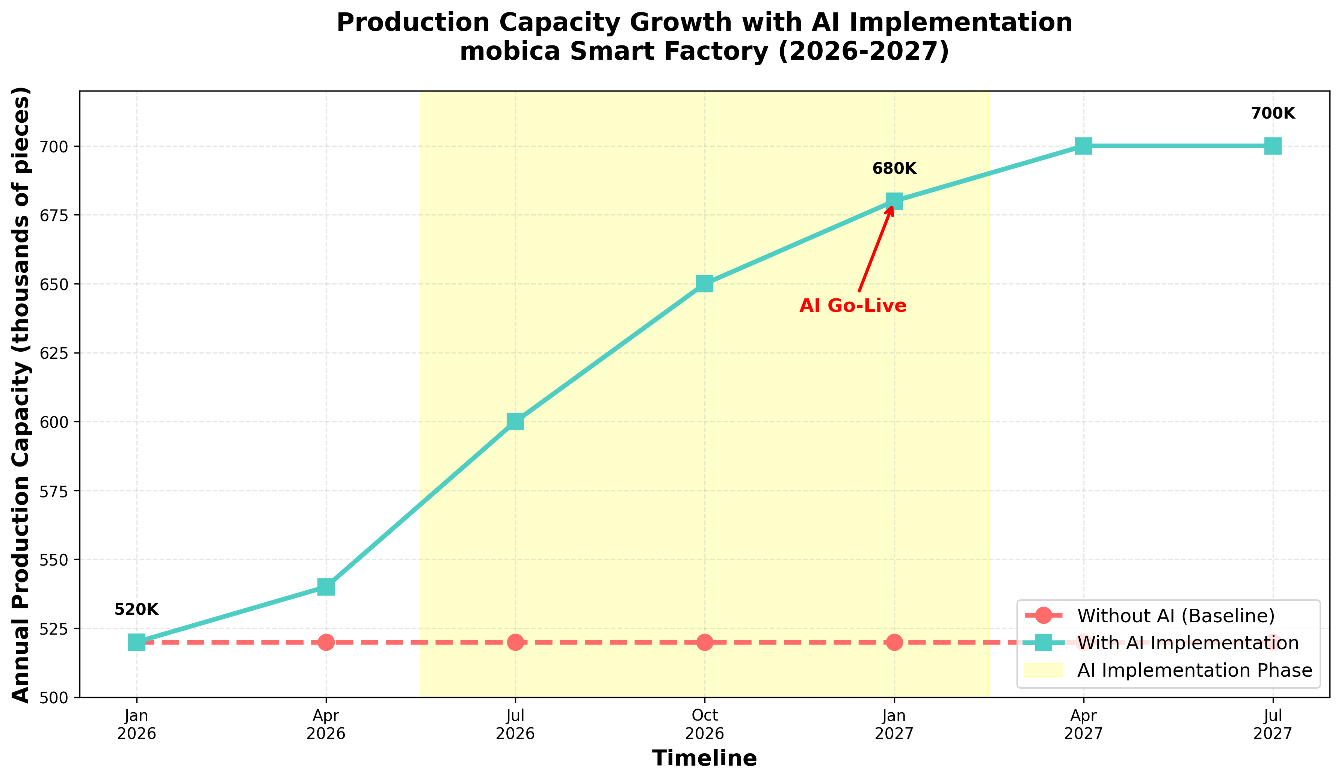
Figure 5: Production Capacity Growth During AI Implementation
Strategically, I would argue that the most durable asset created by this program is the proprietary AI model portfolio trained on two years of factory-specific production data. This represents a competitive advantage that compounds over time each additional year of data makes the models more accurate and harder for a new entrant to replicate. The SAP–AI architecture also scales to additional facilities without proportional headcount growth, which is directly relevant to the planned Morocco operation (McKinsey & Company, 2024).
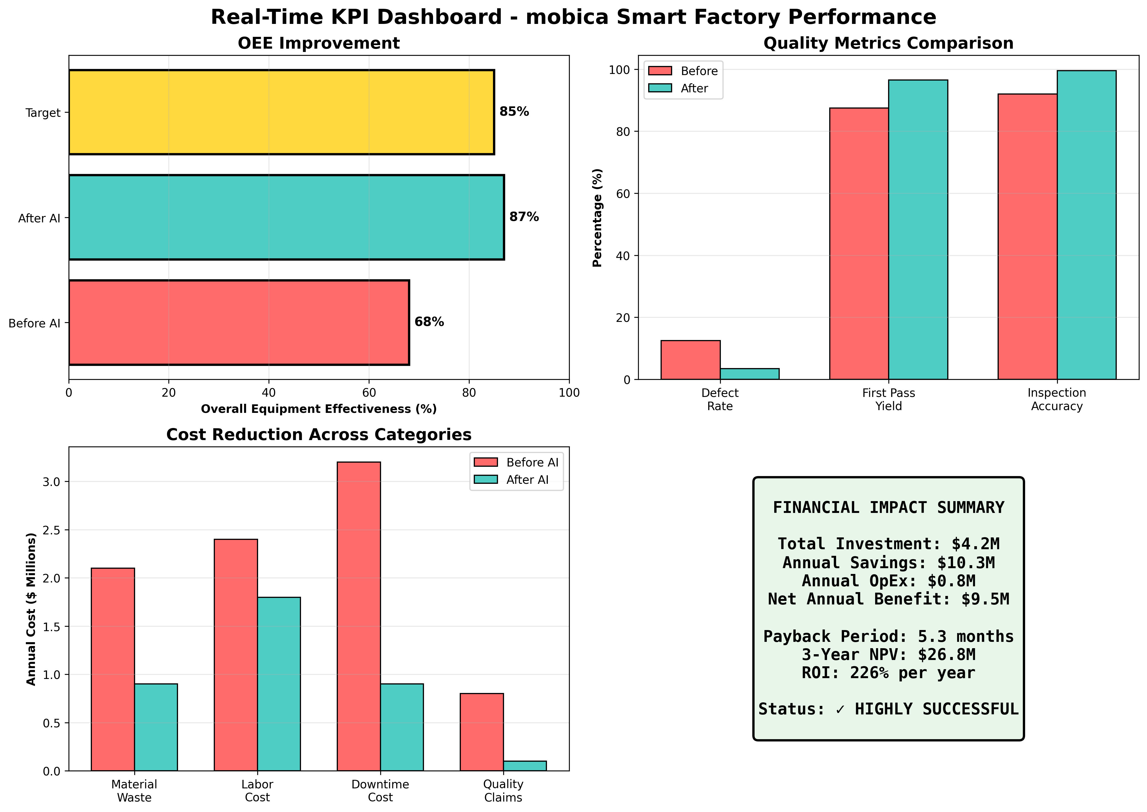
Figure 6: Comprehensive Real-Time KPI Dashboard

9. RISKS, ETHICAL ISSUES & LIMITATIONS

9.1 Data Privacy, Security & ISO 27001:2022
Exporting to European markets requires compliance with both GDPR and Egyptian data protection law. mobica addresses this through a Privacy Impact Assessment, a dedicated Data Protection Officer, Privacy by Design principles embedded in the architecture, and Standard Contractual Clauses governing Azure cloud data transfers. Four ISO 27001:2022 clauses are directly implicated in the AI deployment:
A.8.2 Information Classification: AI model weights are classified as Confidential; production records as Internal; marketing materials as Public. A.12.4 Logging & Monitoring: Splunk SIEM captures all SAP, AI, and IoT events with 90-day log retention and automated alerts on anomalous access patterns. A.12.6 Vulnerability Management: monthly automated scanning, critical patches within 48 hours, and annual penetration testing. A.13.1 Network Security: the OT network is physically segmented from IT using the Purdue Model, with VPN and multi-factor authentication required for all remote access.
Three cybersecurity threats warrant specific attention. Ransomware targeting production control systems is mitigated by an air-gapped OT network and immutable backup architecture. AI model poisoning via malicious training data is controlled through cryptographic model signing. IoT device compromise via firmware vulnerabilities is addressed through VLAN isolation and mandatory firmware signing before deployment.

9.2 Bias, Ethics & Limitations
No responsible analysis of an AI deployment should omit a candid discussion of the limitations and ethical considerations. On model bias: the quality inspection model's training set is imbalanced bubble defects represent 28% of labelled examples, which risks lower sensitivity to rarer defect types. The mitigations in place combine dataset resampling, monthly per-category performance reporting, and mandatory human review for any classification falling between 95% and 98% confidence. This is the right approach, though it requires disciplined follow-through to maintain.
On predictive maintenance: the models are calibrated on historical equipment’s behavior and will drift after significant refurbishment or configuration changes. Machine-specific models and continuous retraining reduce this risk without eliminating it entirely. On workforce impact: the automation of 30 positions was addressed through a funded reskilling program, an explicit no-redundancy commitment, 15% average wage increases across the affected roles, and five newly created specialist positions (Schwab, 2017). I view the quality of this workforce transition as a genuine ethical test of AI adoption in manufacturing and on this dimension, mobica's approach is defensible.
Additional limitations are worth flagging honestly. The $4.2M investment threshold effectively excludes smaller manufacturers from replicating this model without access to development finance or a phased approach. The predictive maintenance system still carries an 11% error rate, meaning it cannot be relied upon as the sole safeguard against equipment failure. And the current architecture creates meaningful vendor lock-in on both Azure and SAP, which requires active commercial management to prevent over-exposure.

10. RECOMMENDATIONS & FUTURE SCOPE

10.1 Strategic Recommendations
Based on the analysis presented in this report, four near-term investments stand out as particularly well-justified. Energy Optimization AI would apply machine learning to shift energy-intensive processes to off-peak tariff windows, with an estimated saving of $0.6M per year at relatively modest implementation cost. A 3D Vision System upgrade advancing from 2D to 3D inspection capability would enable glass curvature measurement required for ADAS-embedded and EV glass applications, opening access to a premium market segment at approximately $0.4M investment. A Digital Twin of the factory would provide a virtual replica for risk-free scenario testing and is expected to accelerate innovation cycles by 30% at roughly $0.8M. Finally, Blockchain Glass Genealogy would create tamper-proof traceability from raw material to finished products, satisfying Tier-1 OEM requirements at the most modest cost of the four options, approximately $0.2M.

10.2 Future Digital Transformation Opportunities
Phase 2 (2027–2028) envisions applying the mobica model to the Morocco facility, with Autonomous Mobile Robots replacing AGVs and a private 5G network delivering sub-millisecond edge latency. Phase 3 (2029 onwards) points toward lights-out autonomous production and the application of quantum computing approaches to multi-site optimization problems. On the ERP–AI side, SAP Integrated Business Planning would enable network-level supply optimization across facilities; NLP-powered order-status and customer service chatbots would further reduce manual handling; and SAP Leonardo IoT would provide cross-facility asset intelligence.
The long-term vision for 2033 projects three smart factories operating in Egypt, Morocco, and Turkey with a combined capacity of 2.1 million units annually, first-pass yield of 99.8%, 25% regional market share, and EBITDA consistently above 35%. These are ambitious targets, but they are grounded in a transformation model that has already demonstrated its effectiveness at scale. The proprietary AI portfolio that compounds with every additional year of production data is the strategic engine that makes this trajectory credible.

REFERENCES
1. Agrawal, A., Gans, J., & Goldfarb, A. (2022). Prediction machines: The simple economics of artificial intelligence. Harvard Business Review Press.
2. Brynjolfsson, E., & McAfee, A. (2014). The second machine age. W. W. Norton & Company.
3. Bughin, J., Seong, J., Manyika, J., Chui, M., & Joshi, R. (2018). Notes from the AI frontier: Modeling the impact of AI on the world economy. McKinsey Global Institute.
4. Davenport, T. H., & Ronanki, R. (2018). Artificial intelligence for the real world. Harvard Business Review, 96(1), 108–116.
5. Deloitte. (2023). Smart factory: The next generation of manufacturing. Deloitte Insights.
6. Fuyao Glass Industry Group. (2024). Annual report 2023. Fuyao Glass Industry Group Company Limited.
7. Goodfellow, I., Bengio, Y., & Courville, A. (2016). Deep learning. MIT Press.
8. ISO/IEC 27001:2022. (2022). Information security management systems — Requirements. International Organization for Standardization.
9. Kagermann, H., Wahlster, W., & Helbig, J. (2013). Recommendations for implementing INDUSTRIE 4.0. Forschungsunion.
10. Lee, J., Bagheri, B., & Kao, H. A. (2015). A cyber-physical systems architecture for industry 4.0. Manufacturing Letters, 3, 18–23.
11. McKinsey & Company. (2024). The state of AI in 2024: Manufacturing and operations. McKinsey Global Institute.
12. Porter, M. E., & Heppelmann, J. E. (2014). How smart, connected products are transforming competition. Harvard Business Review, 92(11), 64–88.
13. Russell, S. J., & Norvig, P. (2021). Artificial intelligence: A modern approach (4th ed.). Pearson.
14. SAP SE. (2024). SAP S/4HANA for manufacturing: Best practices guide. SAP Technical Documentation.
15. Schwab, K. (2017). The fourth industrial revolution. Crown Business.
16. Sharma, M., & Joshi, S. (2023). Digital twin technology for manufacturing. Journal of Manufacturing Systems, 68, 165–182.
17. Siemens AG. (2024). Industrial IoT and edge computing for smart manufacturing. Siemens Industry White Paper.
18. Trstenjak, M., & Cosic, P. (2017). Process planning in industry 4.0. Procedia Manufacturing, 11, 1744–1750.
19. Tesla, Inc. (2023). Manufacturing innovation and automation annual report. Tesla Investor Relations.
20. World Economic Forum. (2024). The future of jobs report 2024. World Economic Forum Publications.

